***A Technical Project Report***

**ON**

***GROCERY LIST ANDROID APPLICATION***

SPS_APL_20220090568***-Virtual Internship - Android Application Development Using Kotlin***



**Prepared by:**

**JAGJOT SINGH**

**jagjotnoor17@gmail.com**

**09/17/2022**

**GROCERY LIST ANDROID**

**APPLICATON**

**Overview:**

Kotlin has boomed in popularity since 2017. Kotlin's concise and expressive syntax is its most beloved feature among educators.Kotlin has many language features to help you avoid common programming mistakes such as null pointer exceptions.

Android Studio is an open and free which is used to develop android application for mobiles, TVs, Watches, and other Android OS, It provides leverage the power of SQL Database and builds an app that shows items added by the user.

***PURPOSE:***

The motive of this project is to build an application to help our users to tackle their day-to-day chaos more effortlessly . goal of this project is to make an app that stores the user items in a cart and can modify and delete the added item in the list. To develop a reliable system, I have some specific goals such as:

1. Develop a system such that users can add item details like product name, product Quantity, and Product Price
2. Develop a database room that is used to store the user data which already been added by the user in the cart and the user can also remove the previously added item in the cart
3. Develop a good UI design that user friendly to the user
4. Develop a good UI that is supported for all android devices

***EXISTING PROBLEM:***

It's not easy for our users to remember everything in such a hectic lifestyle, they frequently can't recall their required necessity they have/want to buy forget . However, with the assistance of this app, user can make a list of the groceries user intend to buy so that user don't forget anything.

**Proposed Solution:**

The grocery list application project will help the user or admin to store the list of items in proper sequence . User /admin can add and remove the items in the list according to his/her will.

1. UI DESIGNTHE IN ANDROID PLATFORM
2. ANDROID APPLICATION DEVELOPMENT
3. DATABASE CONNECTION TO STORE USER DATA

**THEORITICAL ANAYLYSIS**

We are going to build a grocery application in android using android studio. Many times we forget to purchase things that we want to buy, after all, we can’t remember all the items, so with the help of this app, you can note down your grocery items that you are going to purchase, by doing this you can’t forget any items that you want to purchase in this project, we are using ***(MVVM***)for architectural patterns, ***Room***for database, Recycler View and Coroutines to display the list of items.

**Challenges:**

Working with database-friendly UI design for UX Gradle and SDK settings

**REQUIREMENT OF COLLECTION ADN ANALYSIS:**

**3.1 SOFTWARE:**

The Software Package is Developed Using Kotlin and Android Studio. basic SQLCommands Used to Store the Database

Operating System: Windows 11/mac OS/linux

Software: Kotlin and Java

Emulator: Pixel 4 API 30

**3.2 HARDWARE:**

RA : 8GB RAM

ROM: 20GB

*Implementation(Flow of Solution)*

1).I**mplement room database**

**a) Entities class**

The entities class contains all the columns in the database and it should be annotated with @Entity(tablename = “Name of table”). variable name and datatype. We will also add Primary Key for auto-increment.

|  |
| --- |
| The Dao is an interface in which we create all the functions that we want to implement on the database. This interface also annotated with @Dao. Now we will create a function using ction which is a coroutines function. |

**c) Database class**

Database class annotated with @Database(entities = [Name of Entity class.class], version = 1) these entities are the entities array list all the data entities associating with the database and version shows the current version of the database. This database class inherits from the Room Database class. In **GroceryDatabase** class we will make an abstract method to get an instance of DAO and further use this method from the DAO instance to interact with the database.

**d) Now we will implement the architectural structure in the app**

Database class annotated with @Database(entities = [Name of Entity class.class], version = 1) these entities are the entities array list all the data entities associating with the database and version shows the current version of the database.

ViewModel class used as an interface between View and Data. Grocery View Model class inherit from View Model class and we will pass constructor value by creating instance variable of Repository class and stored in repository variable. As we pass the constructor in View Model we have to create another class which is a Factory View Model class.

E) **Factory ViewModel class**

We will inherit the Grocery ViewModel Factory class from ViewModelProvider.NewInstanceFactory and again pass constructor value by creating instance variable of Grocery Repository and return GroceryViewModel(repository).

**Output**

To enter grocery item, quantity, and price from the user we have to create an interface. To implement this interface we will use DialogBox. First create UI of dialog box. In this dialog box we will add three edit text and two text view. Three edit text to enter grocery item name, quantity and price. Two text view one for save and other for cancel.

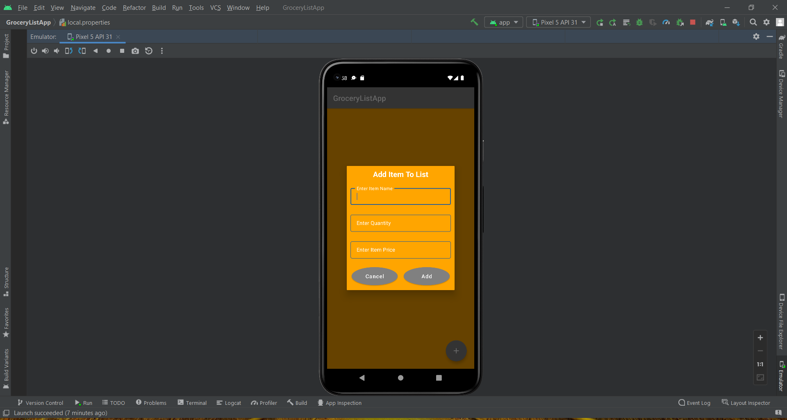

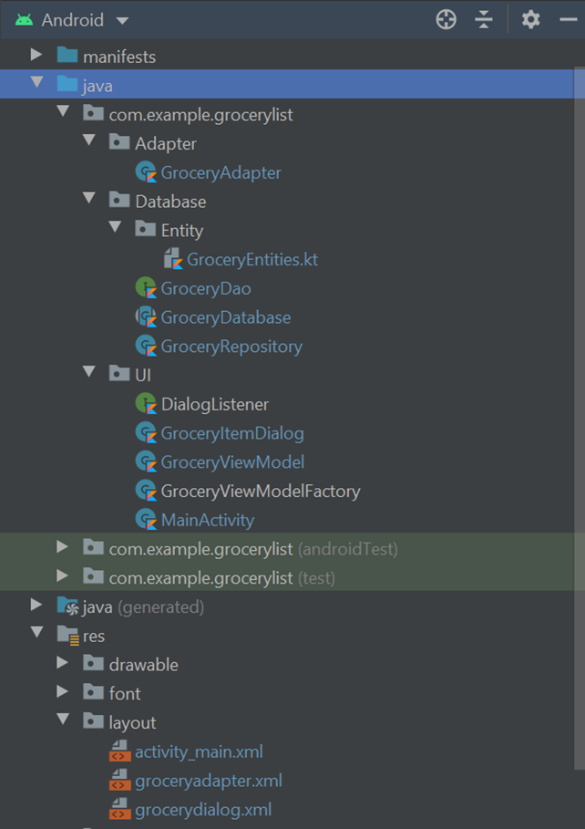

**Conclusion:**

This application will help to store the list of data items include name of item, price and quantity required. Admin can to store his data in list, the application very helpful to user.

**Future Scope:**

This application helps to store the list of items by the Admin. In Future we can also add scheduled addition of items according to reqiurement of user.

The Feature is:

1. Add User Panel
2. Add Admin Panel
3. Provide Login authentication
4. Add image to user product and rating

**REFERENCES:**

1)GitHub URL

<https://github.com/smartinternz02/SPSGP-77350-Virtual-Internship---Android-Application-Development-Using-Kotlin>

2)Demo URL <https://drive.google.com/file/d/1M_oDRw_P1jDik28kyh6RVHPfW5sqkRyC/view?usp=sharing>

**=>Account IDs**

1)GitHub ID <https://github.com/Jagub>

2)Smart Internz ID SPS_APL_20220090568

**ACKNOWLEDGEMENT**

I have taken efforts in this project. However, it would not have been possible without the kind support and help of many individuals and organizations. I would like to extend my sincere thanks to all of them.

I am highly indebted to SMARTINTERNS (Experiential Learning & Remote Externship Platform to bring academia & industry very close for a common goal of talent creation.) for their guidance and constant supervision as well as for providing necessary information regarding the project & also for their support in completing the project.

I would like to express my gratitude towards member of (Organization Name)for their kind co-operation and encouragement which help me in completion of this project.

I would like to express my special gratitude and thanks to industry persons for giving me such attention and time.

My thanks and appreciations also go to people who have willingly helped me out with their abilities.

